**Technical Design Document**

1.0 Revision History <As you revise the document, list what was changed and when it was changed>

Design Document v1.0 - The Initial document

Design Document v1.1 - Formatted document

2.0 Development Environment

2.1 Programming Language and Graphical Framework

Language – C++

Graphical Framework – AIE Bootstrap

2.2 IDE

Microsoft Visual Studio

2.3 Source Control procedures

TortoiseSVN

2.4 Third Party Libraries

2.5 Project Management Tools

<https://app.hacknplan.com/p/93285/dashboards/project>

2.6 Other Software <2d art assets, audio, etc.>

Microsoft Paint

3.0 Timeline

3.1 Milestones

Alpha:

Start Menu Implemented - 30/4/19

Basic Arrows implemented - 5/5/19

Logic Arrows implemented - 10/5/19

Score implemented - 12/5/19

Beta:

Testing - 13/5/19

Gold:

Game completed - 15/5/19

4.0 Game Overview

4.1 Gameplay

Basic game of Simon Says where the user is given directions on which arrows to press. If the user presses the wrong button or takes too long to press a button, the game will end. Their score will increase with consecutive correct inputs.

4.2 Game Objects and Logic

Menu buttons – Play and Quit buttons, play button starts the game, quit button closes the program.

Arrows – Arrows correspond to the arrows on the user’s keyboard, if they press the corresponding arrow, their score increases and it displays another arrow. If they press an arrow which is not shown, the game will end.

4.3 Game Flow

From the start menu, the player can choose to click the play button or quit button. Once they press play, the game will start and an arrow will pop up on the screen, the player will need to press the corresponding arrow key on their keyboard to score more points. If they press the wrong arrow key, the game over screen will show and prompt the player to press the escape key. Once the escape key is pressed, it will return the player back to the menu where they can press the quit button to close the program.

5.0 Mechanics

Player’s will press the corresponding arrows that are shown in order to increase their score.

6.0 Game Architecture

6.1 Classes

Game Class – Used to display the menu and other visual aspects of the game itself.

Arrow Class – Holds all data regarding arrows.

7.0 UI and HUD

7.1 Heads-Up Display 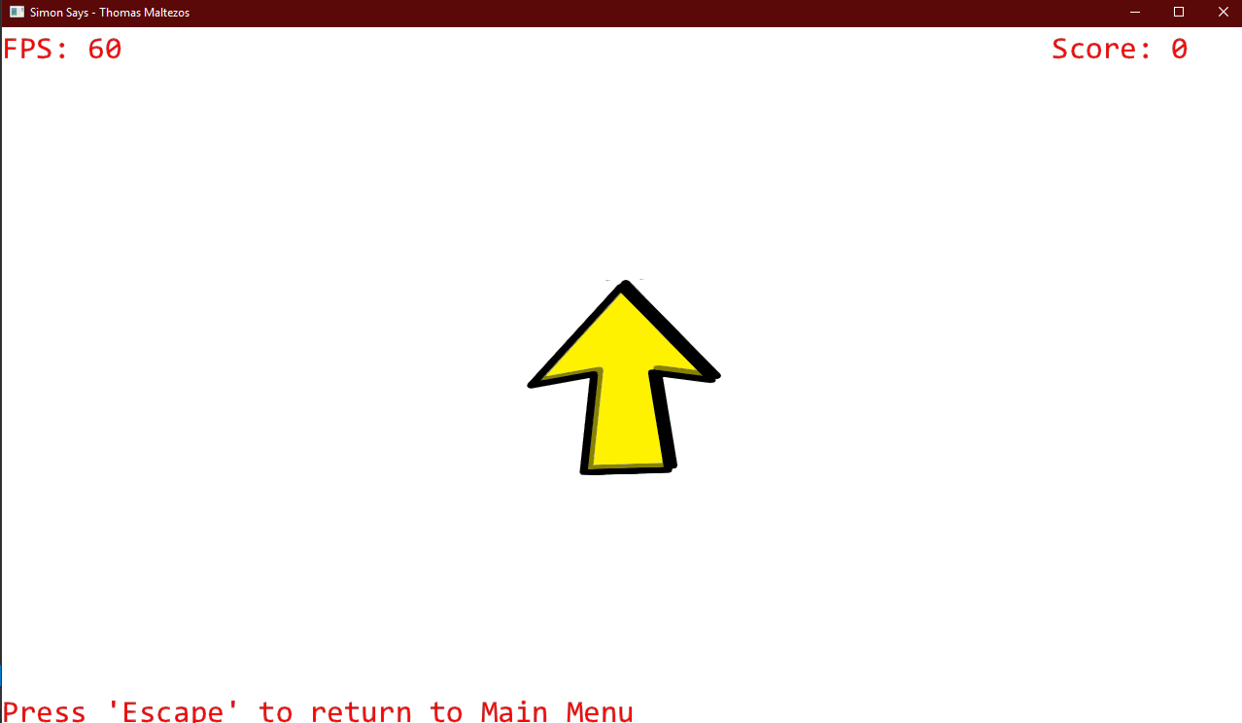

7.2 User-Interface

